DAY -2

Document Version: 1.0

Date: 27/01/2026

DAY: TUESDAY

Prepared By: Testing & Documentation Team

UI COMPONENTS TEAM:

MODULE 5: TIME TRACKING

Introduction:
Time tracking in UI components involves measuring the time users spend interacting with different interface elements. It helps analyze user behavior, evaluate performance, and improve overall user experience.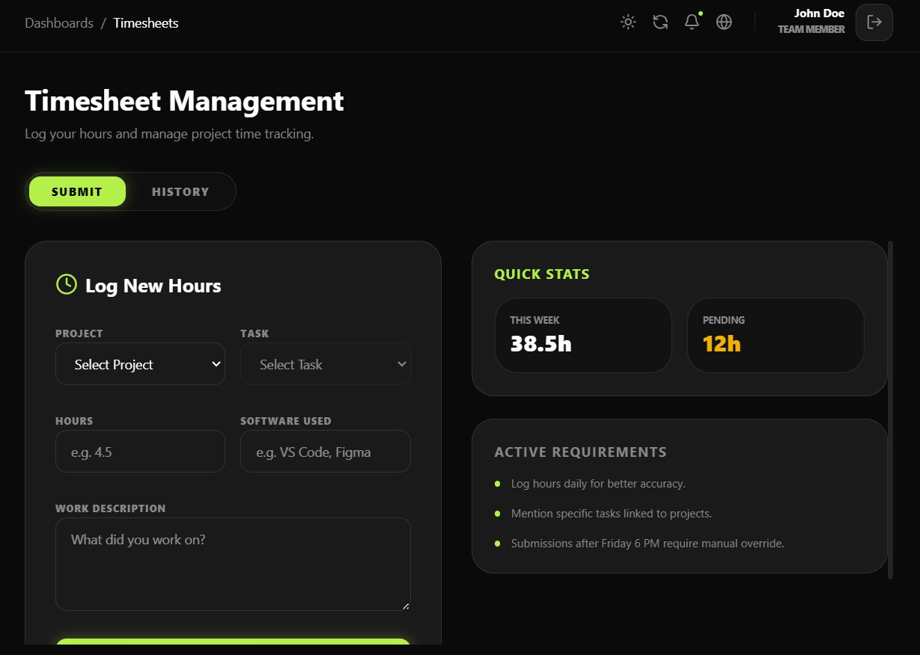

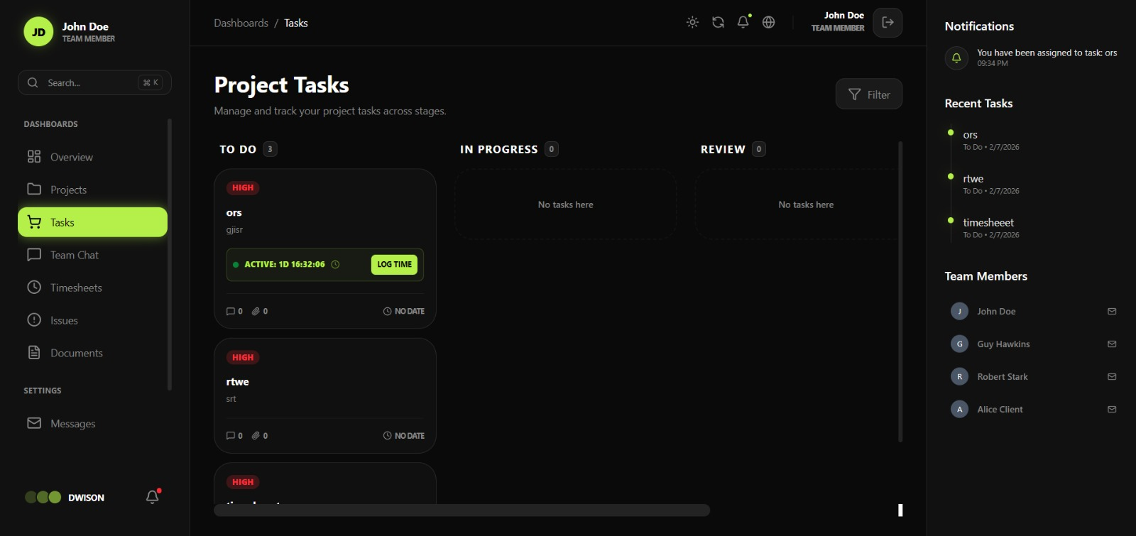MODULE 6: COLLABRATION & COMMUNICATION

Introduction:
Collaboration and communication in UI components enable users to interact, share information, and work together within an application. These components support features such as messaging, notifications, shared views, and real-time updates, helping improve teamwork, coordination, and overall user engagement.
SCREENSHOT: PENDING
Description: PENDING

DASHBOARD DEVELOPMENT TEAM:

MODULE 2: PROJECT MANAGEMENT

Introduction:
Project management in dashboard development involves planning, organizing, and monitoring tasks to ensure the project is completed on time and meets requirements. The dashboard helps track progress, manage resources, and provide a clear overview of project activities.
SCREENSHOT: PENDING
Description: PENDING

MODULE 4: MILESTONE & PHASES

Introduction:
Milestones and phases in dashboard development represent key stages and important goals of the project. They help track progress, organize work, and ensure the project moves forward in a planned and structured manner.
SCREENSHOT:
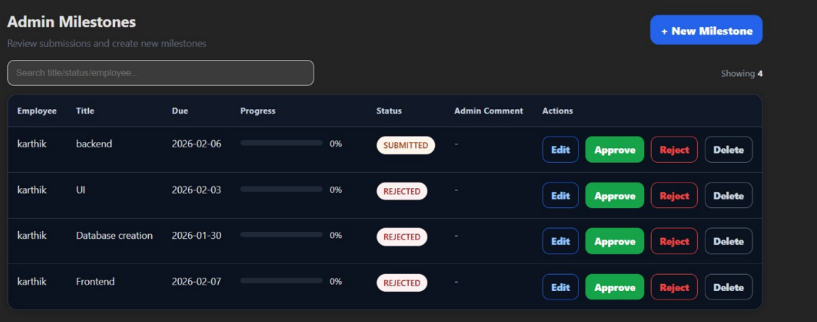
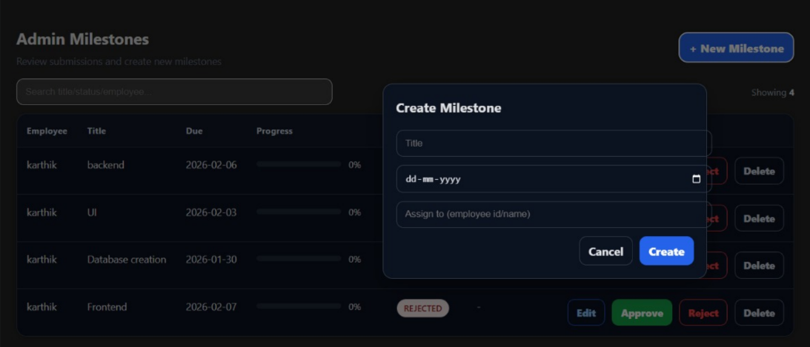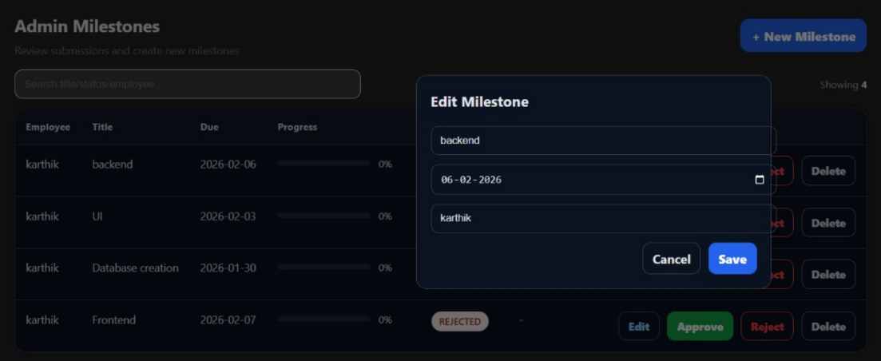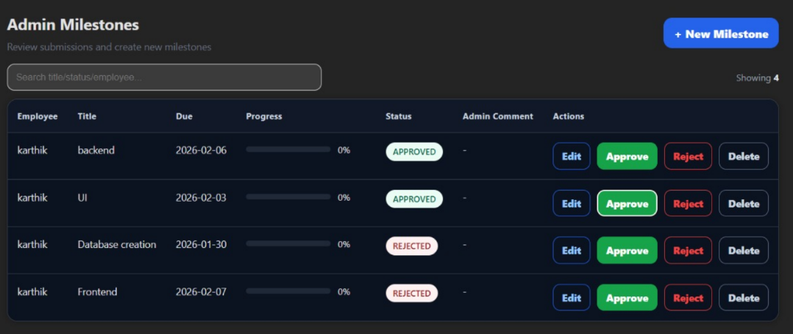Description:
Admin Milestone Management
An admin milestones section was created in the dashboard.
Admins can create new milestones and assign them to employees.
Admins can edit milestones and review employee submissions.
Admins can approve, reject, or delete milestone updates as needed.

TASK MANAGEMENT TEAM:

MODULE 7: ISSUE & BUG TRACKING:

Introduction:
Issue and bug tracking in task management involves identifying, recording, and resolving problems that occur during project execution. It helps teams monitor issues, assign responsibilities, and ensure timely fixes for smooth project progress.
SCREENSHOT: PENDING
Description: PENDING

MODULE 12: DASHBOARD VIEWS

Introduction:
Dashboard views in task management provide a clear and organized display of tasks, progress, and status updates. They help users quickly understand project information and manage work efficiently.
SCREENSHOT: 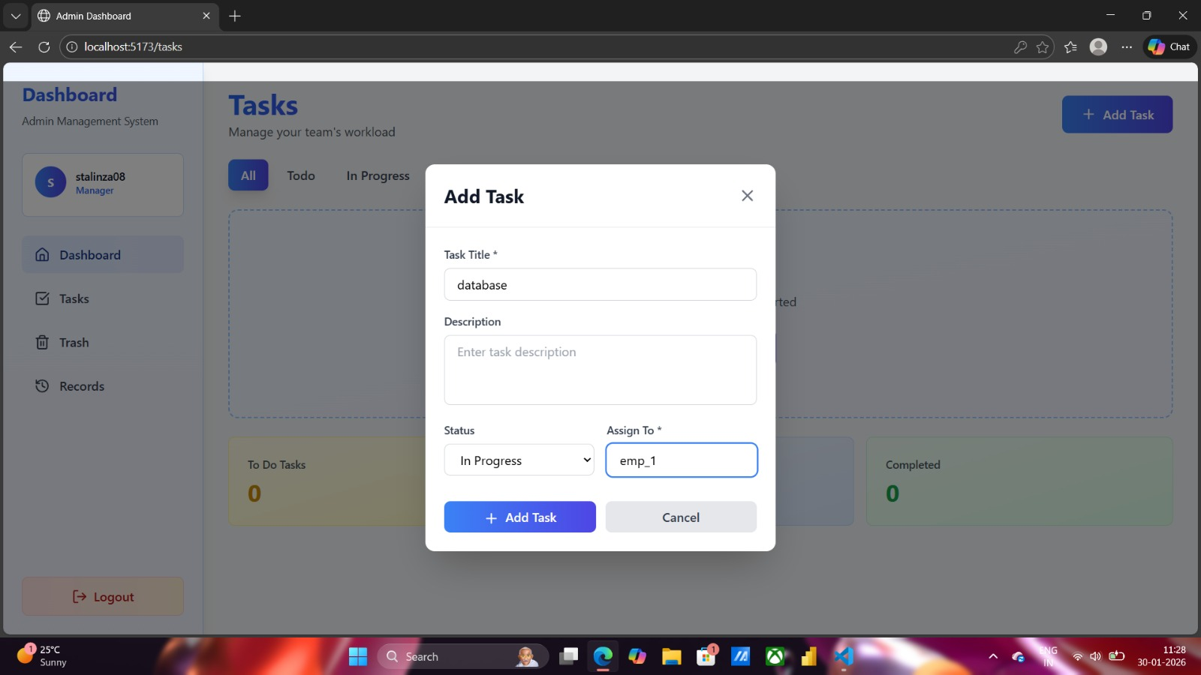
Description: Task Creation & Assignment
A task was created and assigned to Employee 1. The task was successfully added to the To-Do list, enabling tracking and management of assigned work through the dashboard.

ANALYTICS & REPORT TEAM:

MODULE 9: REPORT & ANALYTICS:

Introduction:
Reports and analytics provide meaningful insights by collecting and analyzing project data. They help track performance, identify trends, and support better decision-making through clear visual and statistical information.
SCREENSHOT: PENDING
Description: PENDING

MODULE 10: NOTIFICATION & ALERTS

Introduction:
Notifications and alerts in analytics and reports inform users about important updates, changes, or critical events. They help ensure timely awareness and quick action based on data insights.
SCREENSHOT: PENDING
Description: PENDING

DESIGN & UX TEAM:

MODULE 1: AUTHENTICATION & ORGANIZATION:

Introduction:
Authentication and organization setup in design and UX ensure secure access and proper user management within the application. They help users sign in safely, define roles, and organize teams for a smooth and consistent user experience.

SCREENSHOT: 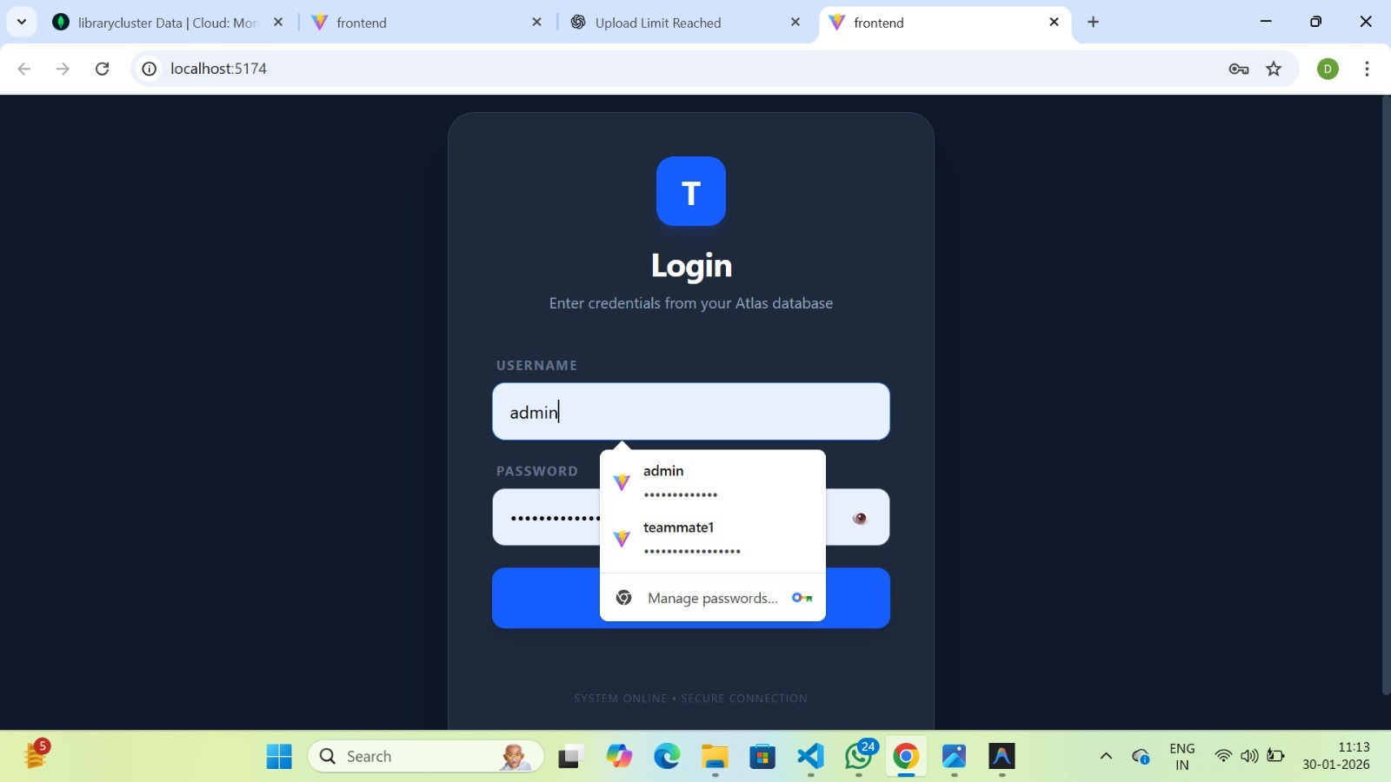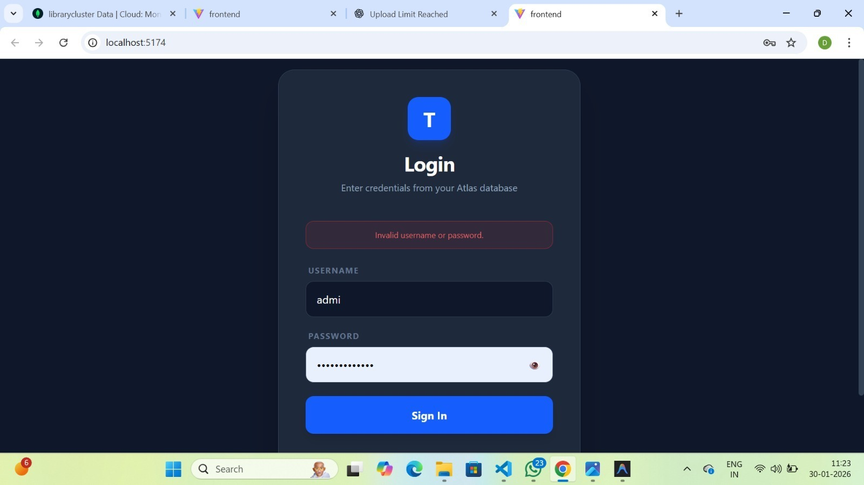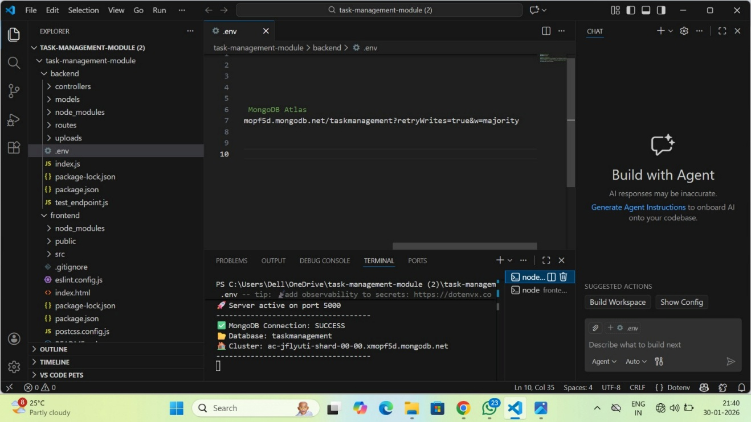
Description:
Authentication
Implemented backend functionality for the login system. Created a login API using Node.js and connected the application to MongoDB Atlas. Developed a user model and enabled validation of login credentials by sending data from the frontend to the backend. The system now verifies whether the user exists and returns appropriate success or error responses.

MODULE 10: TASK MANAGEMENT

Introduction:
Task management in design and UX focuses on organizing, assigning, and tracking tasks in a user-friendly manner. It helps users plan work efficiently and ensures a smooth and intuitive experience.
SCREENSHOT: 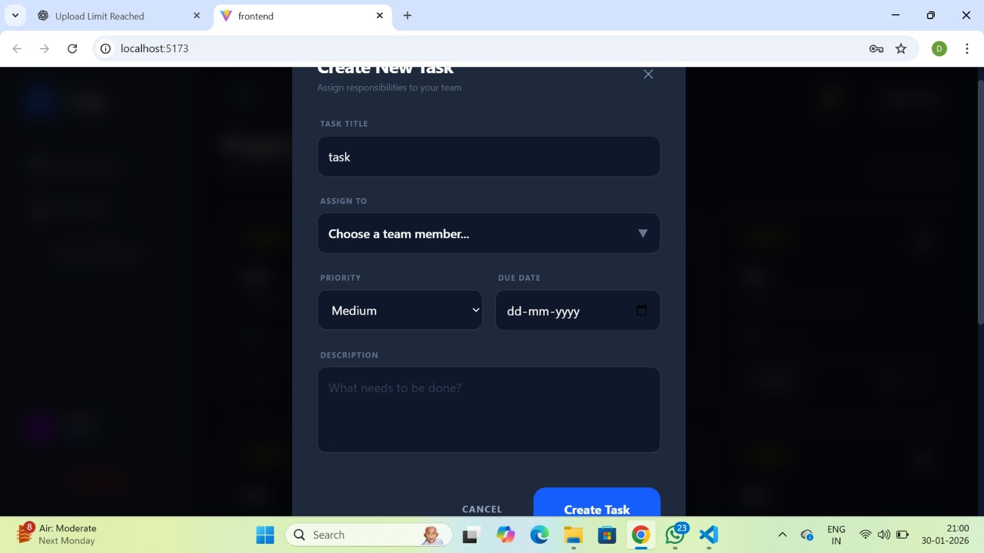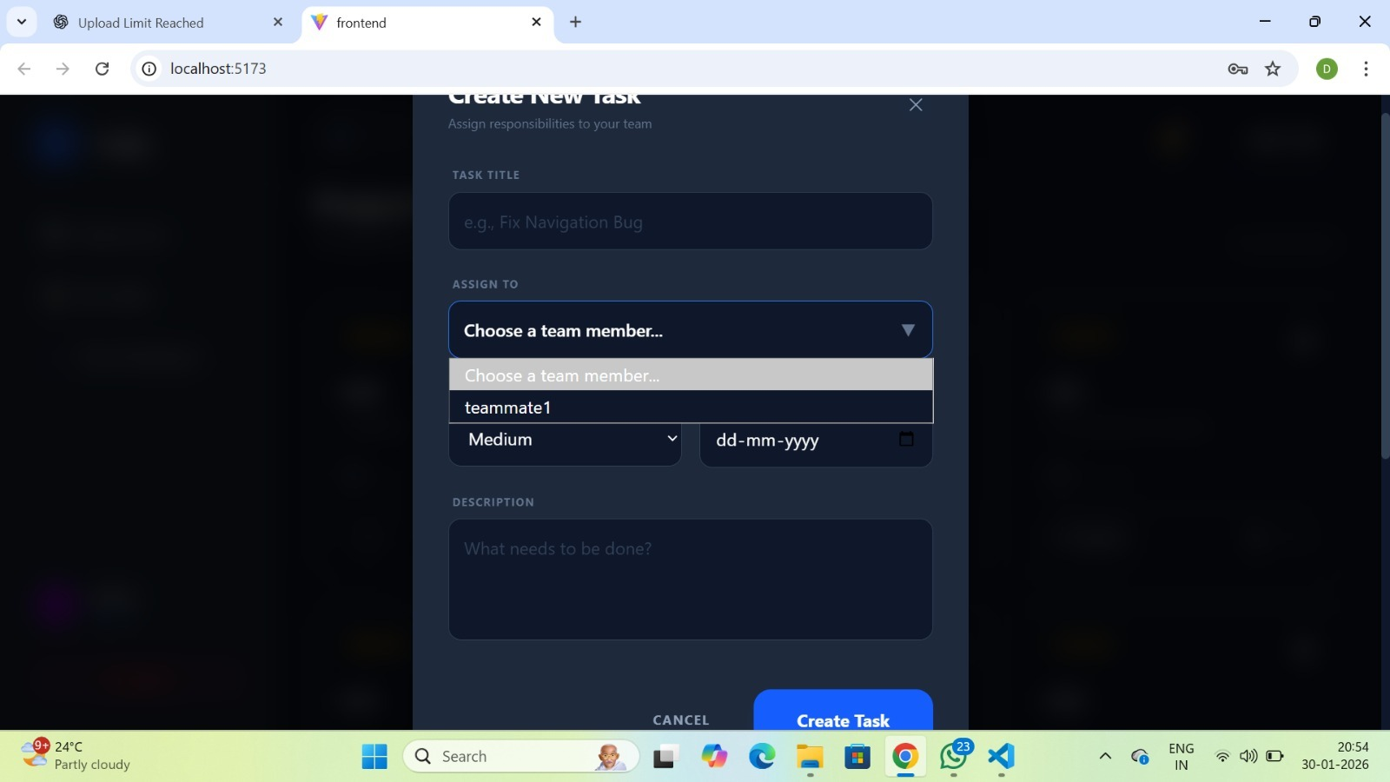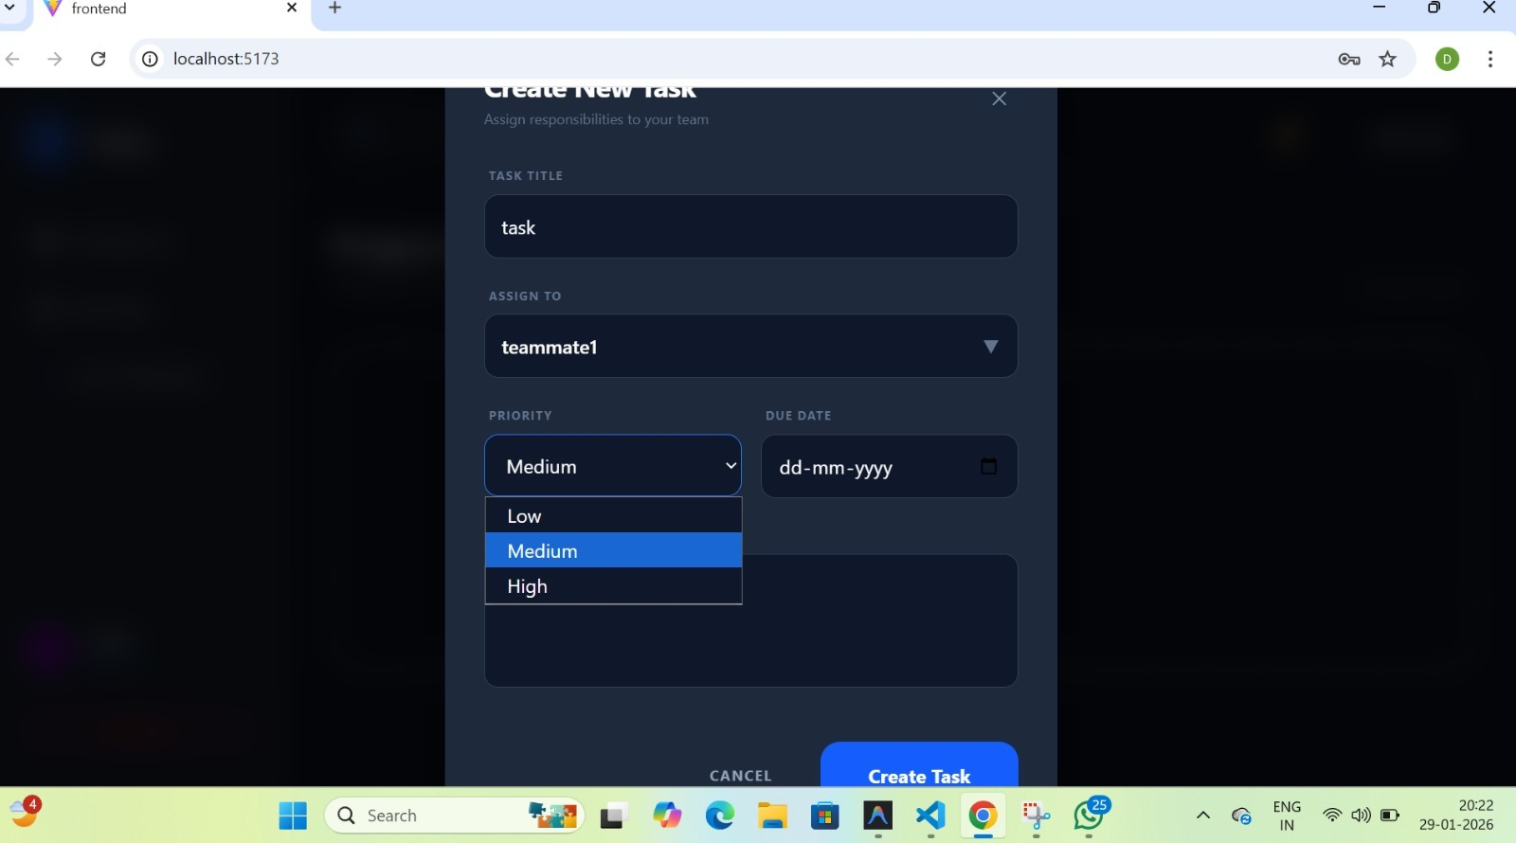
Description:
Task management
Improved the Create Task page by making all input fields fully functional. Implemented state management in React to capture task name, description, priority, and due date dynamically. Ensured the form correctly collects user input and prepares the data to be sent to the backend. This made the task creation form interactive and ready for reliable task submission.

